QC Project Overview
This project was created largely off of David Rach’s InstrumentQC website. He created a “how-to” tutorial that was followed very closely during the creation of this site. That how-to can be found here: https://davidrach.github.io/InstrumentQC_Install/. The main deviations from this tutorial involve scripts that do not mesh with how the FHCC performs daily QC, and will be addressed on a case by case basis.

File Directory
- Set up in the documents folder of all computers
- Each computer contains a (mostly) complete copy of the project files
  - Exceptions are the log files generated each time the script runs on an instrument computer, those are only saved locally
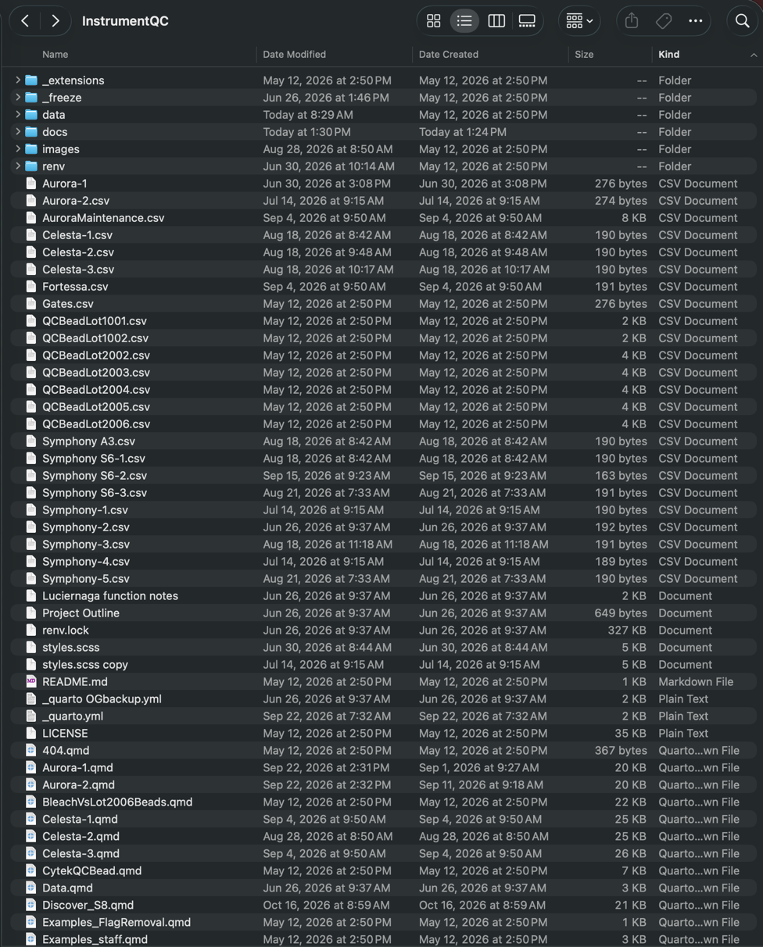
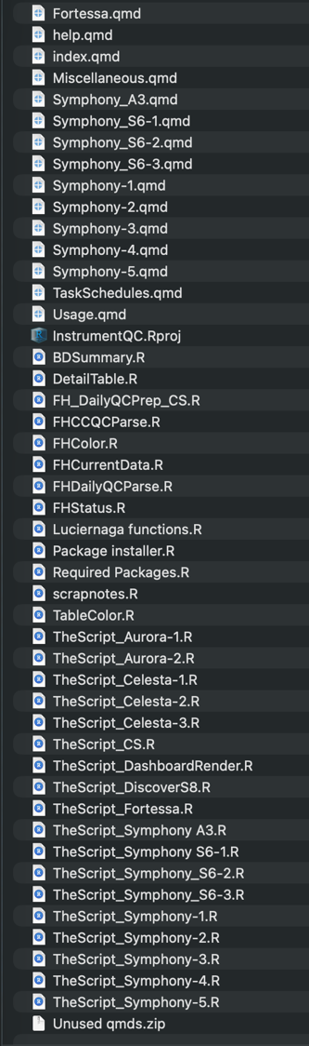

All files present in project directory at time of writing

Folders
Used by quarto for rendering webpages

Contains individual instrument folders with historical QC data
Contains .html and .pdf copies of all webpages
Contains images used by website
Unused, can be used for R package version control

Data folder
- Contains subfolders for each instrument
- Specific contents of each subfolder depends on instrument type. These files are the ones edited daily at each instrument computer by their individual scripts and are used to generate the webpages
  - Auroras have three .csv’s
    - ‘Application’ csv: Record of every SIT flush performed, used to track usage
    - ‘Archived’ csv: Record of SpectroFlo QC reports
    - ‘Bead’ csv: Record of QbSure bead recordings. Stats are derived from 2nd peak of QbSure beads.
  - Conventional BD instruments have one .csv
    - ‘Holistic’ csv: Record of UR bead recordings
  - Spectral BD instruments have two .csv’s
    - ‘Detector’ csv: Record of QC for fluorescent detectors
    - ‘Imaging’ csv: Record of QC for imaging detectors. Data is not currently displayed anywhere on website, just recorded for potential use.
- HistoricalData.csv: Currently only implemented for Aurora instruments. Used on UMGCC site for storage of data older than a year.
- AppData.csv: Combination of SIT flush data for all Auroras for usage tracking
- QCPlots pdfs: Generated by .qmd files during website rendering, contains individual detector plots

